Factors related to COVID-19 severity and mortality based on comparison between Henan and Zhejiang: an observational study
Wangquan Ji, Ruonan Liang, Peiyu Zhu, Haiyan Yang, Shuaiyin Chen, Weiguo Zhang, Yuefei Jin* and Guangcai Duan*
Department of Epidemiology, College of Public Health, Zhengzhou University, Zhengzhou 450001, China.

Supplementary materials
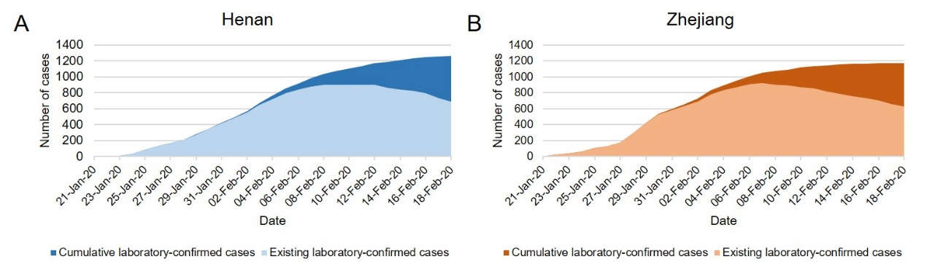
Fig.1 An overview of COVID-19 epidemic in Henan and Zhejiang Province (A): The number of cumulative/existing laboratory-confirmed cases in Henan; (B) The number of cumulative/existing laboratory-confirmed cases in Zhejiang.

Province and variables | Zhejiang n (%) | Henan n (%) | χ2 | P
Overview of age
0-18 | 30(2.8%) | 53(4.2%) | 3.402 | 0.065
Others | 1044(97.2%) | 1205(95.8%) | 3.402 | 0.065
Total | 1074(100%) | 1258(100%)
19-35 | 220(20.5%) | 363(28.9%) | 21.653 | <0.001
Others | 854(79.5%) | 895(71.1%) | 21.653 | <0.001
Total | 1074(100%) | 1258(100%)
36-59 | 604(56.2%) | 652(51.8%) | 4.534 | 0.033
Others | 470(43.8%) | 606(48.2%) | 4.534 | 0.033
Total | 1074(100%) | 1258(100%)
≥60 | 218(20.3%) | 190(15.1%) | 10.831 | 0.001
Others | 856(79.7%) | 1068(84.9%) | 10.831 | 0.001
Total | 1074(100%) | 1258(100%)
Imported case age
19-35 | 115(24.0%) | 244(36.4%) | 20.023 | <0.001
Others | 364(76.0%) | 426(63.6%) | 20.023 | <0.001
Total | 479(100%) | 670(100%)
Urban case age
≥60 | 180(21.6%) | 104(16.7%) | 5.598 | 0.021
Others | 654(78.4%) | 517(83.3%) | 5.598 | 0.021
Total | 834(100%) | 621(100%) | 5.598 | 0.021
Table 1. Detailed comparison of age groups

